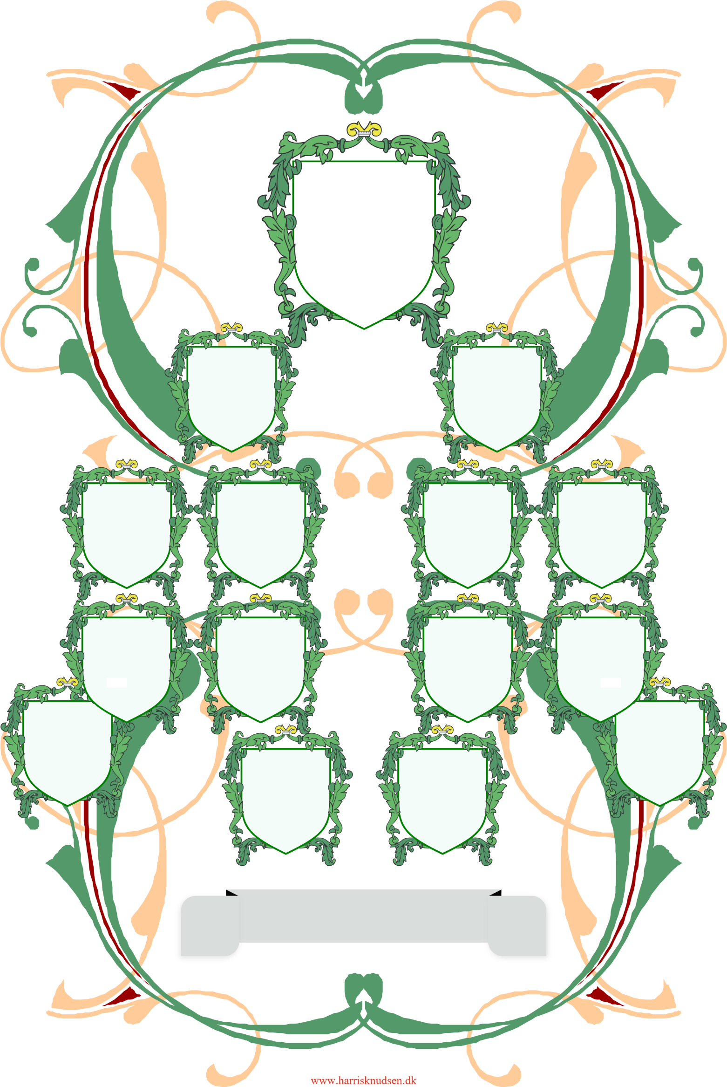

Familien Holmsland

Carl

Erik Emil

Holmsland

1897 – 1978

1