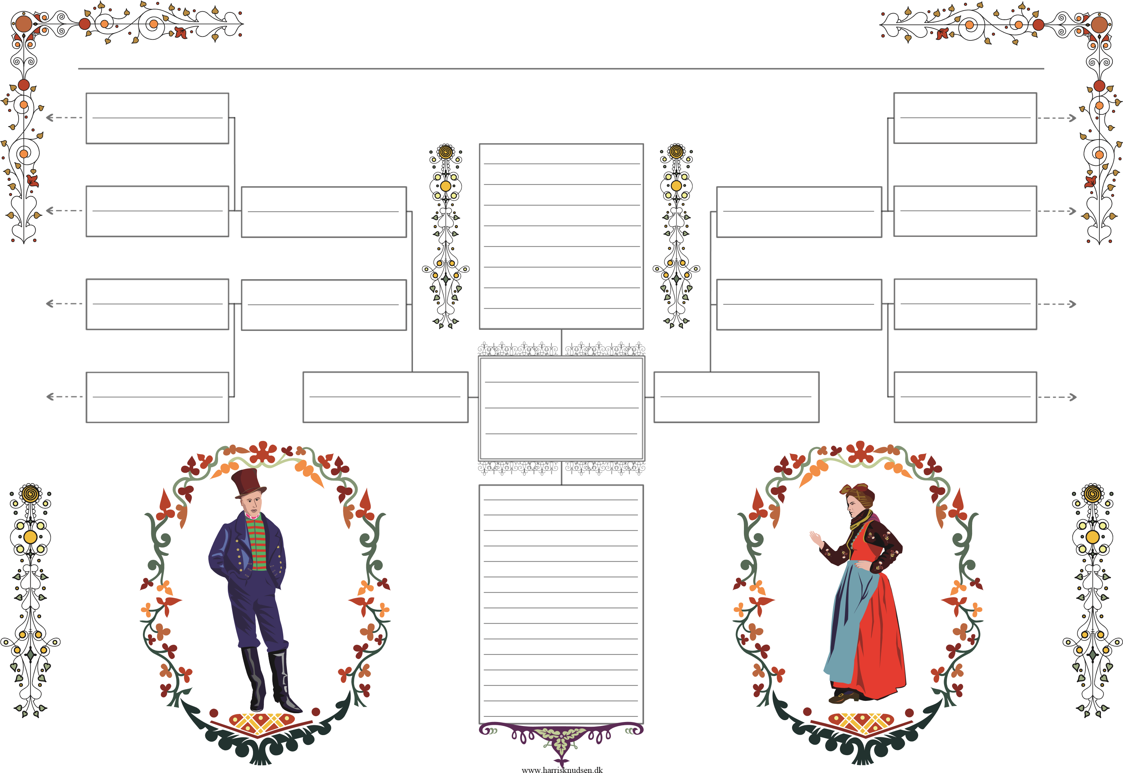

Ægtefælle/r

123

1900 - 1900

Times New Roman

123

1900 - 1900

Times New Roman

123

1900 - 1900

Times New Roman

123

1900 - 1900

Times New Roman

123

1900 - 1900

Times New Roman

123

1900 - 1900

Times New Roman

123

1900 - 1900

Times New Roman

123

1900 - 1900

123

1900 - 1900

Times New Roman 10

123

1900 - 1900

123

1900 - 1900

Times New Roman 10

Times New Roman

123

1900 - 1900

Times New Roman 10

123

1900 - 1900

Times New Roman 10

Times New Roman 8

Times New Roman 9

123

1900 - 1900

Times New Roman 10

123

1900 - 1900

Times New Roman 11

Times New Roman 24